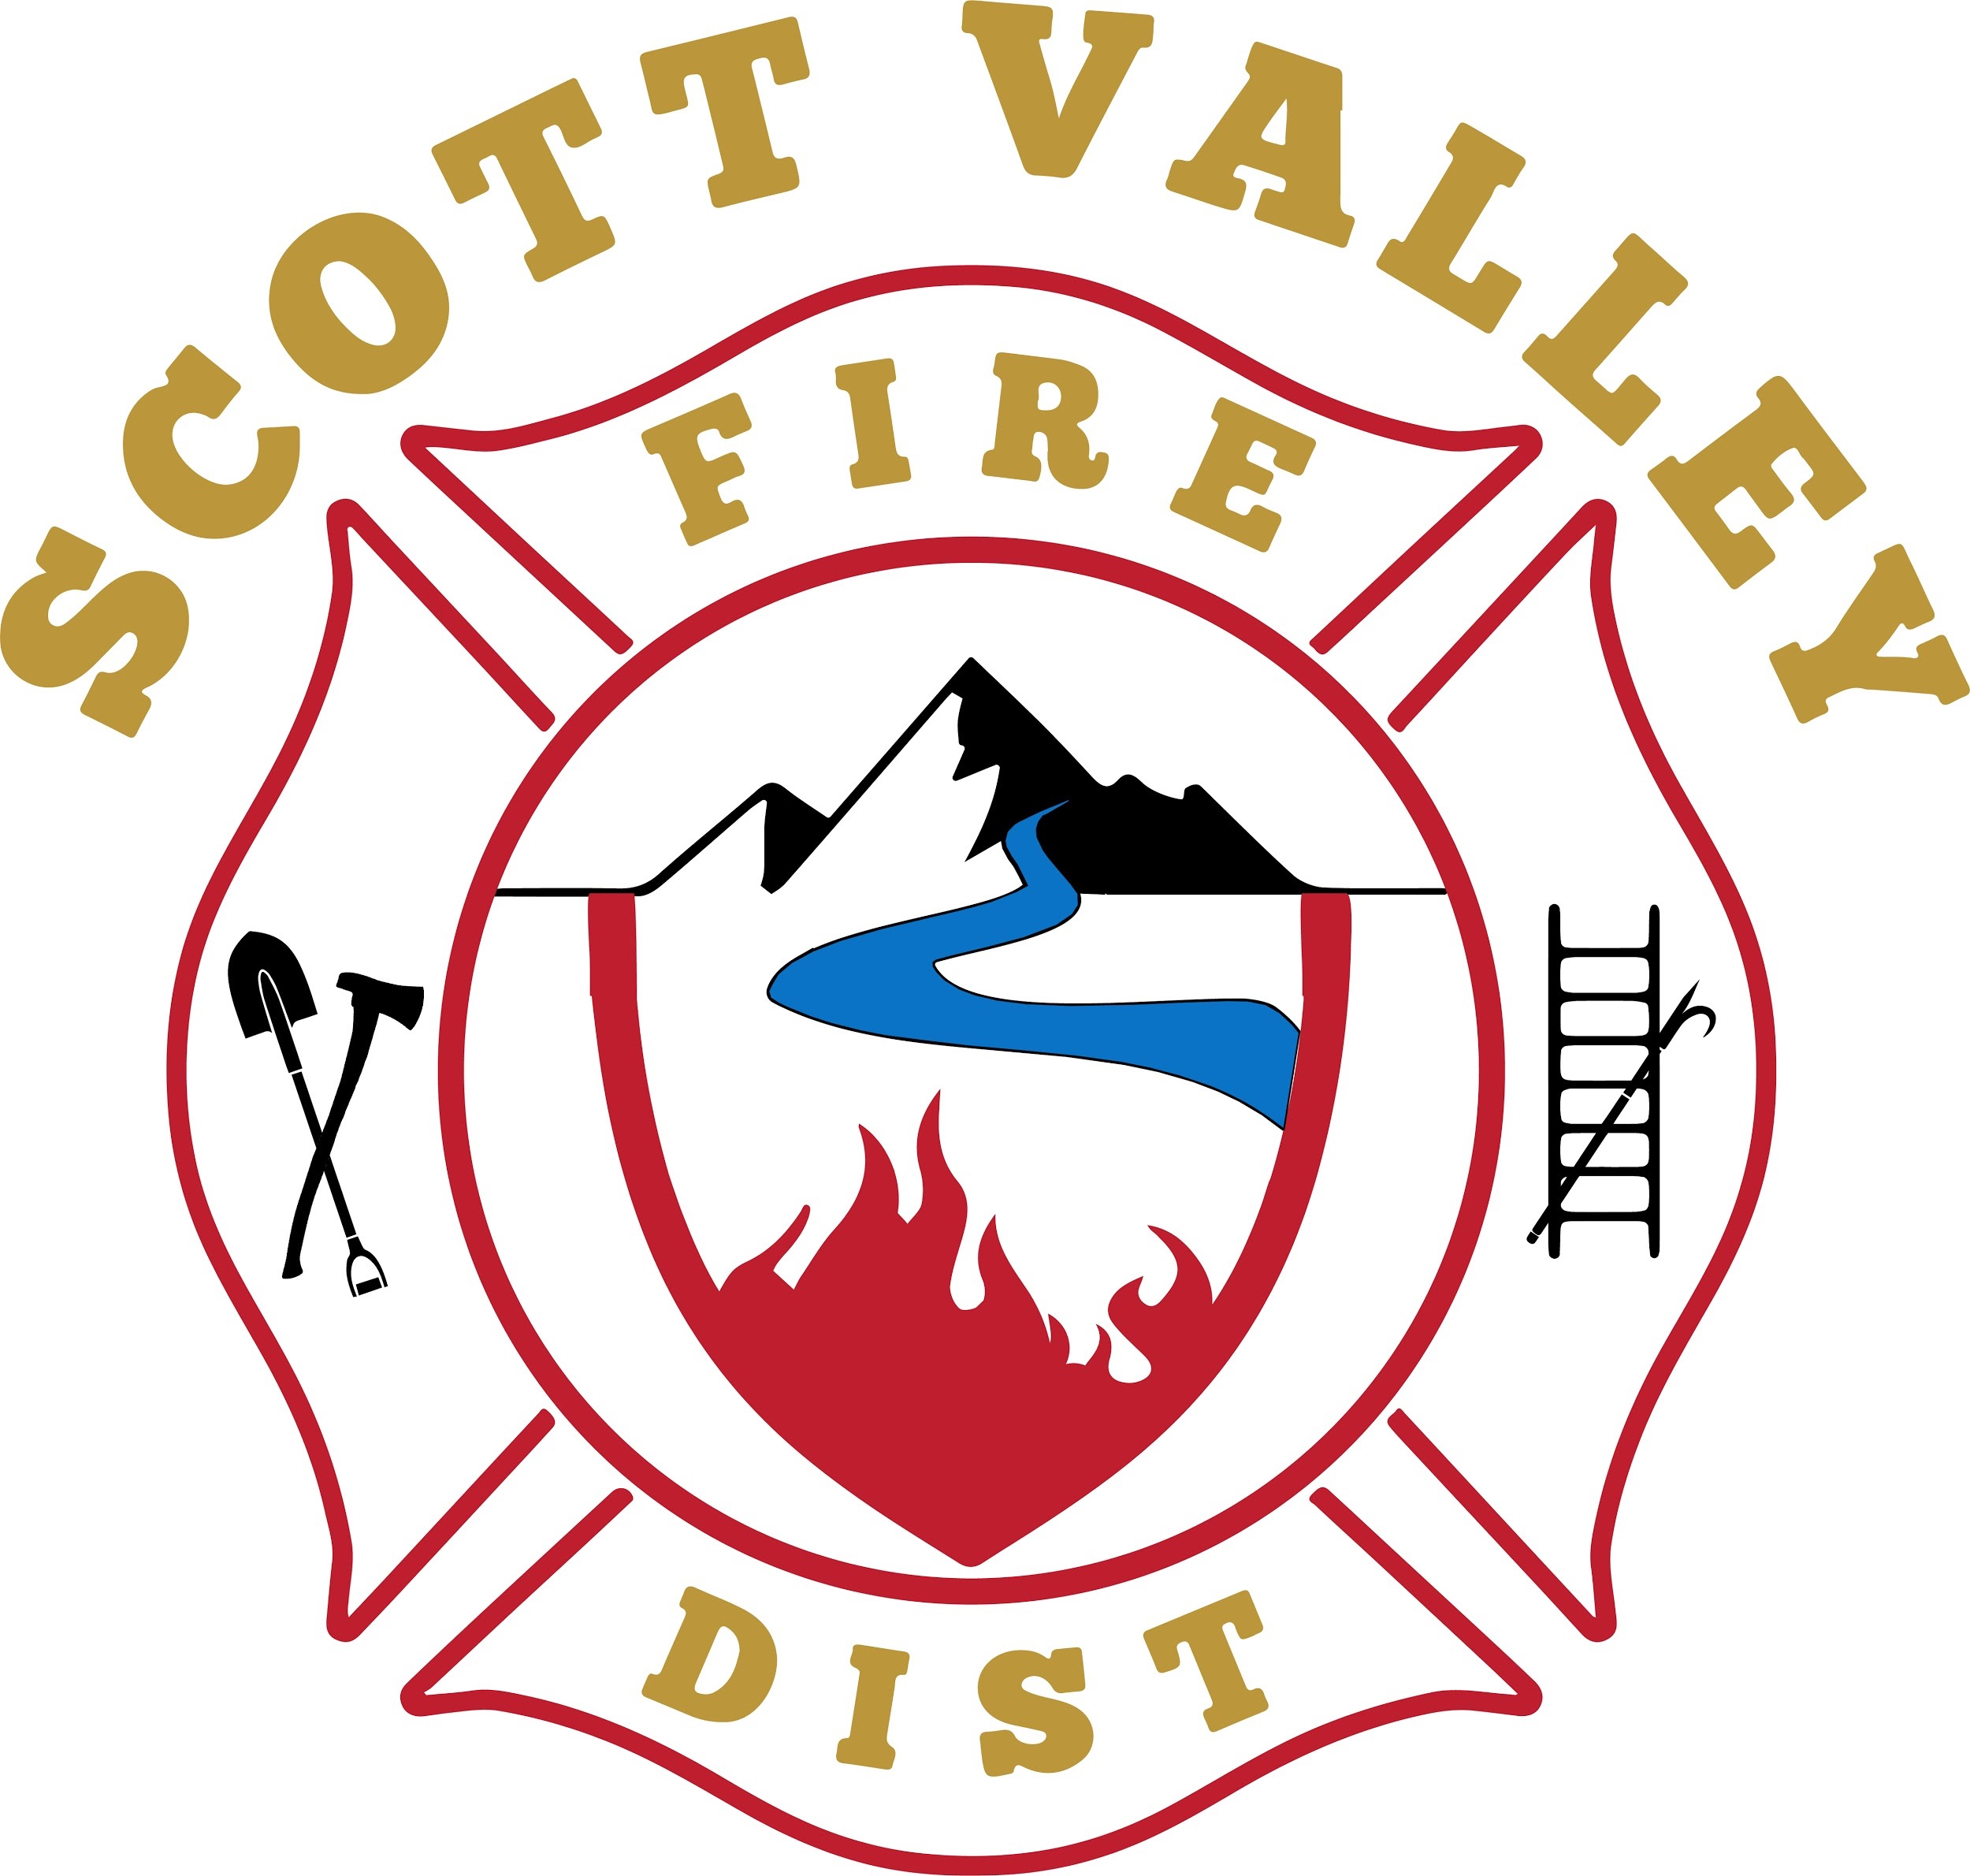

SCOTT VALLEY FIRE PROTECTION DISTRICT
A California Special District
Siskiyou County, California
P.O. Box 130, Greenview, C A 96037
(530) 468-2170 messages only
Location: Fire Hall, 317 Maple St.
Greenview, CA. 96037
http://www.scottvalleyfire.com

Chief Paul Buchter
530-598-7249 pbuchter@live.com

Assistant Chief Steve Poling
530 340-3245 C1501poling@gmail.com

Administrator Nancy Salucci
541 210-4618 joy@mind.net

Board of Commissioners:
Larry Alexander, Chair
Kathleen Williams
Kevin Hullquist
Greg Lindholm
Jennifer Frick

SVFPD BOARD AGENDA Thursday, March 14, 2024 5:30p.m.

The Board will convene in an open session of a REGULAR MEETING at 5:30p.m.
in the SVFPD fire hall at 317 Maple Ave., Greenview.

Public report period: Speakers should stand and address the Board.
Public comments are limited to five minutes and to topics of interest to the Board. Discussion may not occur at this time.

Board member reports:

Larry Alexander, Chair pro tempore (Public Information Officer, Grants,
Fire Safe Council Liaison)
Approval of minutes from February 8, 2024
Continuing/New business

Kathy Williams-- Excused absence
(Personnel, Sunshine Committee; Dalmatians liaison)
Dalmatians report
Continuing/New business

Kevin Hullquist (Insurance Oversight)
Short- and long-range Board plans
Continuing/New business

Greg Lindholm--Excused Absence
(Training Center/Building Oversight)
Hiring resiliency rep for public feasibility survey
Assembly Bill (AB570 23-24) update
Continuing/New business

Jennifer Frick
Investing District Funds with California Class
Grant research up-date
Continuing New business

Administrative Officer Salucci
Monthly revenue deposits; transfers
SDRMA quote for Liability & Equipment Insurance 2024-25
Pancake Breakfast proposal
Continuing/New business

Operations reports: Chief Paul Buchter and Asst. Chief Steve Poling
Alliance (formerly “Consolidation) meeting report
Paying FJ Chief Hess for firefighter training courses
Training Center Update
Continuing/New business

