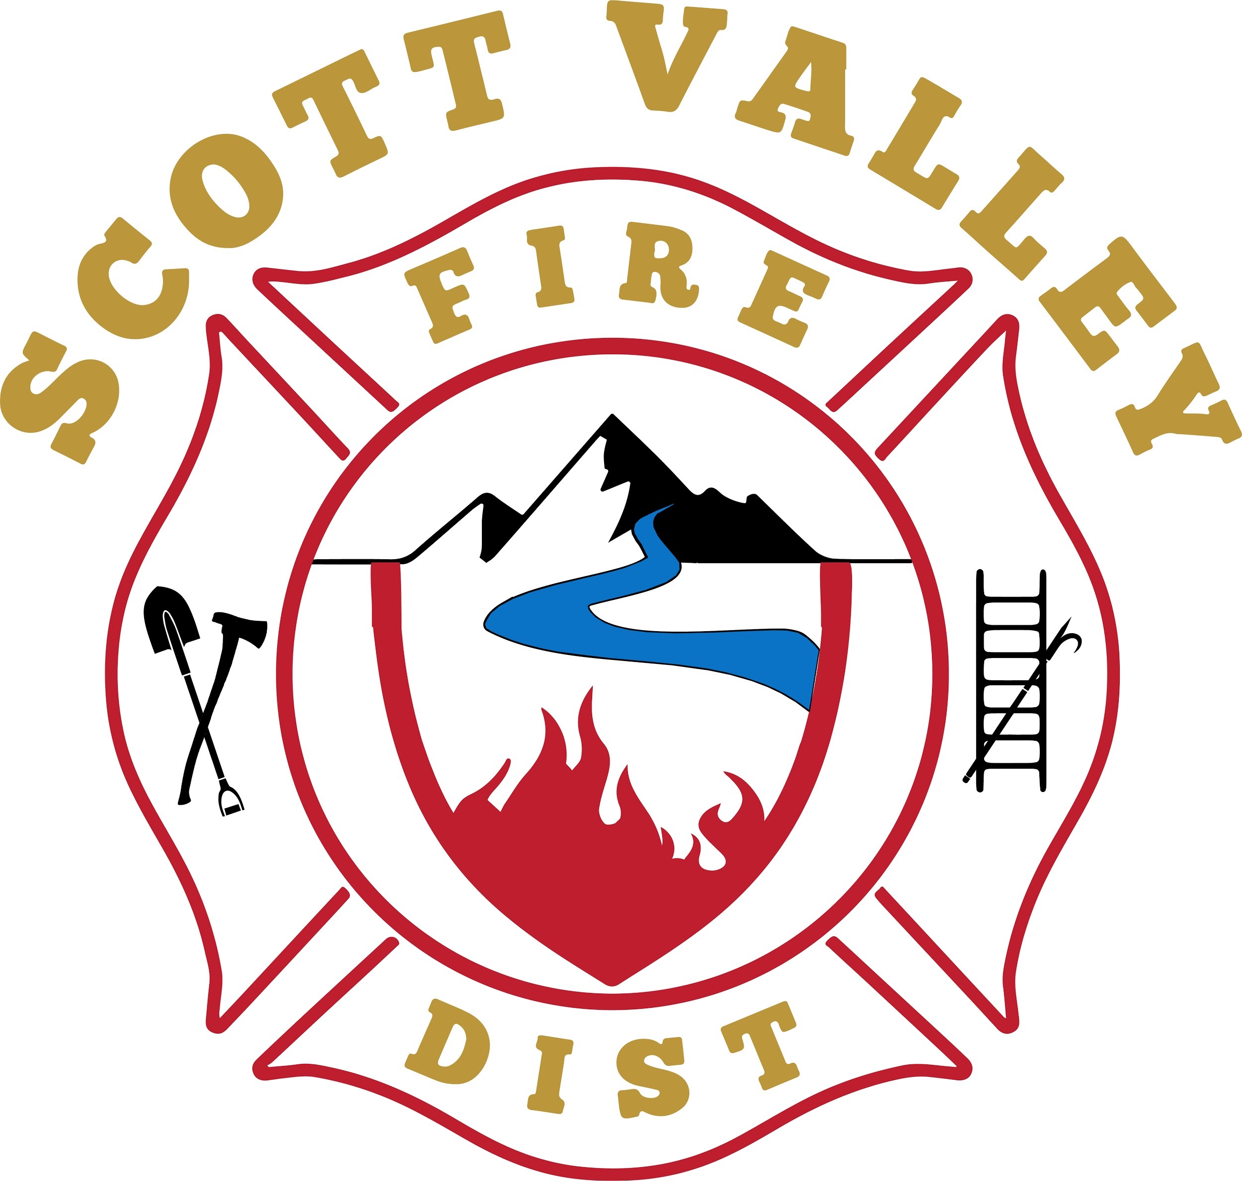
SVFPD BOARD AGENDA Thursday, November 10, 2020

SCOTT VALLEY FIRE
PROTECTION DISTRICT
A California Special District Siskiyou County, California
P.O. Box 130, Greenview, CA 96037
(530) 468-2170 messages only
Location: Fire Hall, 317 Maple St.
Greenview, CA. 96037
http://www.scottvalleyfire.com

Chief Paul Buchter
530-598-7249 pbuchter@live.com

Assistant Chief Scott Frick
530 643-1413 svfiechief1501@yahoo.com

Administrator Nancy Salucci
541 210-4618 joy@mind.net

Board of Commissioners:
Larry Alexander, Chair
James C. Roseman, Vice Chair
Jay Akerman
Kathleen Williams
Kevin Hullquist

The Board will then convene in an open session of a REGULAR MEETING at 1700 hours (5:00p.m.) in the SVFPD fire hall at 317 Maple Ave., Greenview, CA.
NOTE NEW WINTER MEETING TIME of 5:00.
NOTE Tuesday meeting rather than Thursday, this month only.
The Governor’s COVID-19 guidelines including social distancing and wearing protective masks will be followed.

Public report period: Speakers should stand and address the Board.
Public comments are limited to five minutes and to topics of interest to the Board. Discussion may not occur at this time.

CLOSED SESSION: Personnel

Administrative Officer Salucci
Monthly revenue deposits, approval and payment of bills; acceptance of donations
Dalmatians financial report
Grant application for solar-powered water fill sites.
Oral communications, correspondence, continuing/new business

Board member reports:
Larry Alexander, Chair (Public Info Officer, Grants, Fire Safe Council Liaison)
Approval of minutes from October meeting
Oral Communication; correspondence; continuing/new business

James C. Roseman, Vice Chair (Personnel) Excused absence

Jay Akerman (Fiscal Oversight/Insurance)
Continuing/New business

Kathy Williams (Sunshine Committee)
Continuing/New business

Kevin Hullquist (Training Center Coordinator)
Continuing/New business

Operations reports:
Chief Paul Buchter
Assistant Chief position(s)
RESOLUTION re Greenview Station lot line adjustment; authorizing Chief to represent SVFPD
New and/or pending firefighter applications. Final approval of applicants.
Update on status of “chaser’ vehicle for strike team participation
Training/Safety/Injury and Illness Prevention Program monthly report
Continuing/New business

